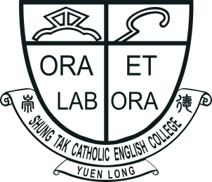 |  | SHUNG TAK CATHOLIC ENGLISH COLLEGE  ‘All Write Now!’  English Writing Competition 2024  Application Form  (Please use a separate form for each entry.) |  | 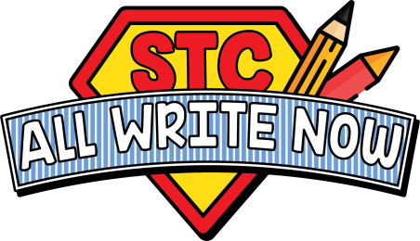
Name of Student: |  |  | Current Level: |  | Primary ☐ 5 / ☐ 6
Contact Number: |  |  | Email:
Name of School:
Responsible Teacher:
Contact Number: |  |  | Email:

(Please enter your work in the text box below. Start a new page as needed.)
All entries should be submitted via email to allwritenow@stc.edu.hk
Submission Deadline: Friday 1st November, 2024

